LOAN EXCEPTION REQUEST PROCESS
Loan Exception Requests for Prior Approvals
The Loan Exception Request Form must be completed in its entirety and uploaded as a ‘CREDIT FILE’ through Image Central along with the complete loan file. Please review the Underwriting Submission Checklist for documentation when submitting a file for Prior Approval.
This applies both to delegated and non-delegated clients. The loan will go through the setup process before being assigned to an underwriter for review. The underwriter will submit the exception request, once the loan is reviewed.
Loan Exception Requests for Closed Loans
The Loan Exception Request Form must be uploaded through Image Central as Document Type ‘Exception Requests’ along with the CD evidencing the loan has closed, along with any applicable documentation needed to review the request for exception.
Exception Requests for Condo Waivers, Escrow Waivers or Systems
The System Exception Request Form must be completed indicating the appropriate reason for the exception and uploaded through Image Central as Document Type ‘Exception Requests’. See the System Exception Request Form for detailed requirements.
Click image for larger view
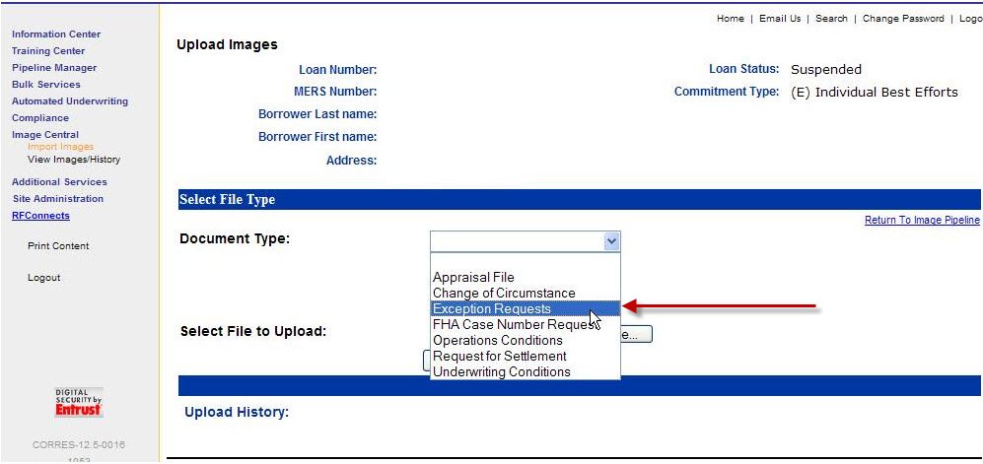

Loan Exception Request Form – Systems

Registration/System Requests, Escrow Waivers, Condominium Warranties and Other

All Exception Requests require a complete file to be submitted to us for Underwriting unless the request is identified in the Specific Exception Request Area below or if the loan has closed.

Upload through Image Central as “Exception Requests”

INVESTOR LOAN NUMBER IS REQUIRED

********(No status calls for 48 hours)********
877-700-4622
Granted Exceptions may incur an additional price adjustment
Borrower And Correspondent Information
Today’s Date Client ID Loan #
Borrower Name Co-Borrower Name

Subject Property Address
Requestor Name Email

Phone # Return Fax #

Specific Exception Requests Information – PRIOR APPROVAL
Escrow Waiver

Name of Current Lender

Does Current Lender hold escrow? Yes No

Condominium Warranty Waiver

Current Guideline

Reason/Description for Request

(Please review the Condo Chapter in Client Guide for required documentation)
Registration/Lock LTV Exceptions

Other (Delegated Correspondent)

Other (Non-Delegated Correspondent)

Other (Wholesale)

**FOR INTERNAL USE ONLY - Do not write below this line**
CREDIT policy |  |  | SIGNATURE |  |  |  |  | DATE
 | Approved |  |  | Denied |  | Pending: Additional information is necessary to evaluate this request. If you wish to proceed with this request, submit the complete loan file for consideration. This notification is not a denial of an application and may not be communicated as such to your customer.
 | Not a Credit Policy Request
Conditions / Comments:
**Approved exceptions are NULL AND VOID IF ALL CONDITIONS ARE NOT MET**
CONDITIONS APPLICABLE TO ALL APPROVED EXCEPTIONS:
- Loan must meet all other program requirements
- Any change to loan characteristics (LTV/CLTV, Loan Amount, DTI, Reserves, etc.) requires resubmission for review, approval and pricing
- Exceptions may be subject to additional pricing adjustments
- Closed loans must be purchased within 30 days of exception approval date

